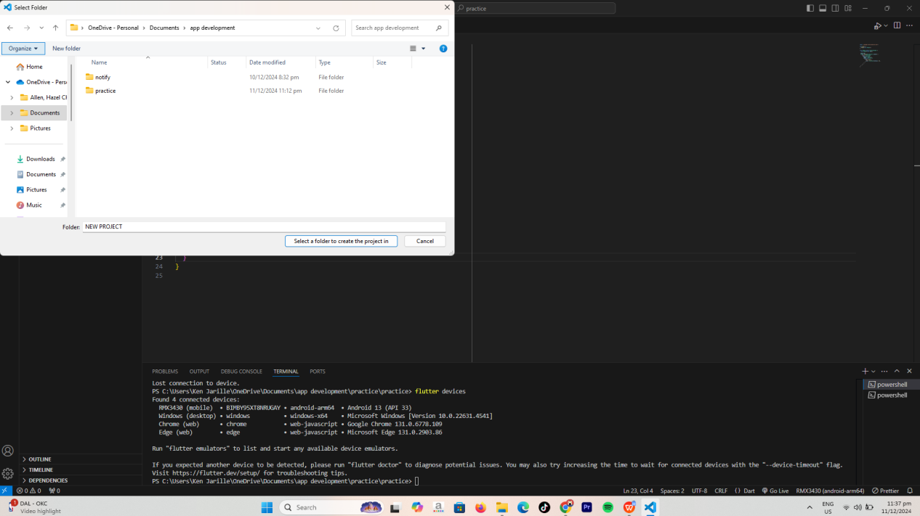CREATING NEW PROJECT  
  
  
  
  
  
  
  
  
  
  
  
  
  
  
  
  
  
  
  
  
  
  
  
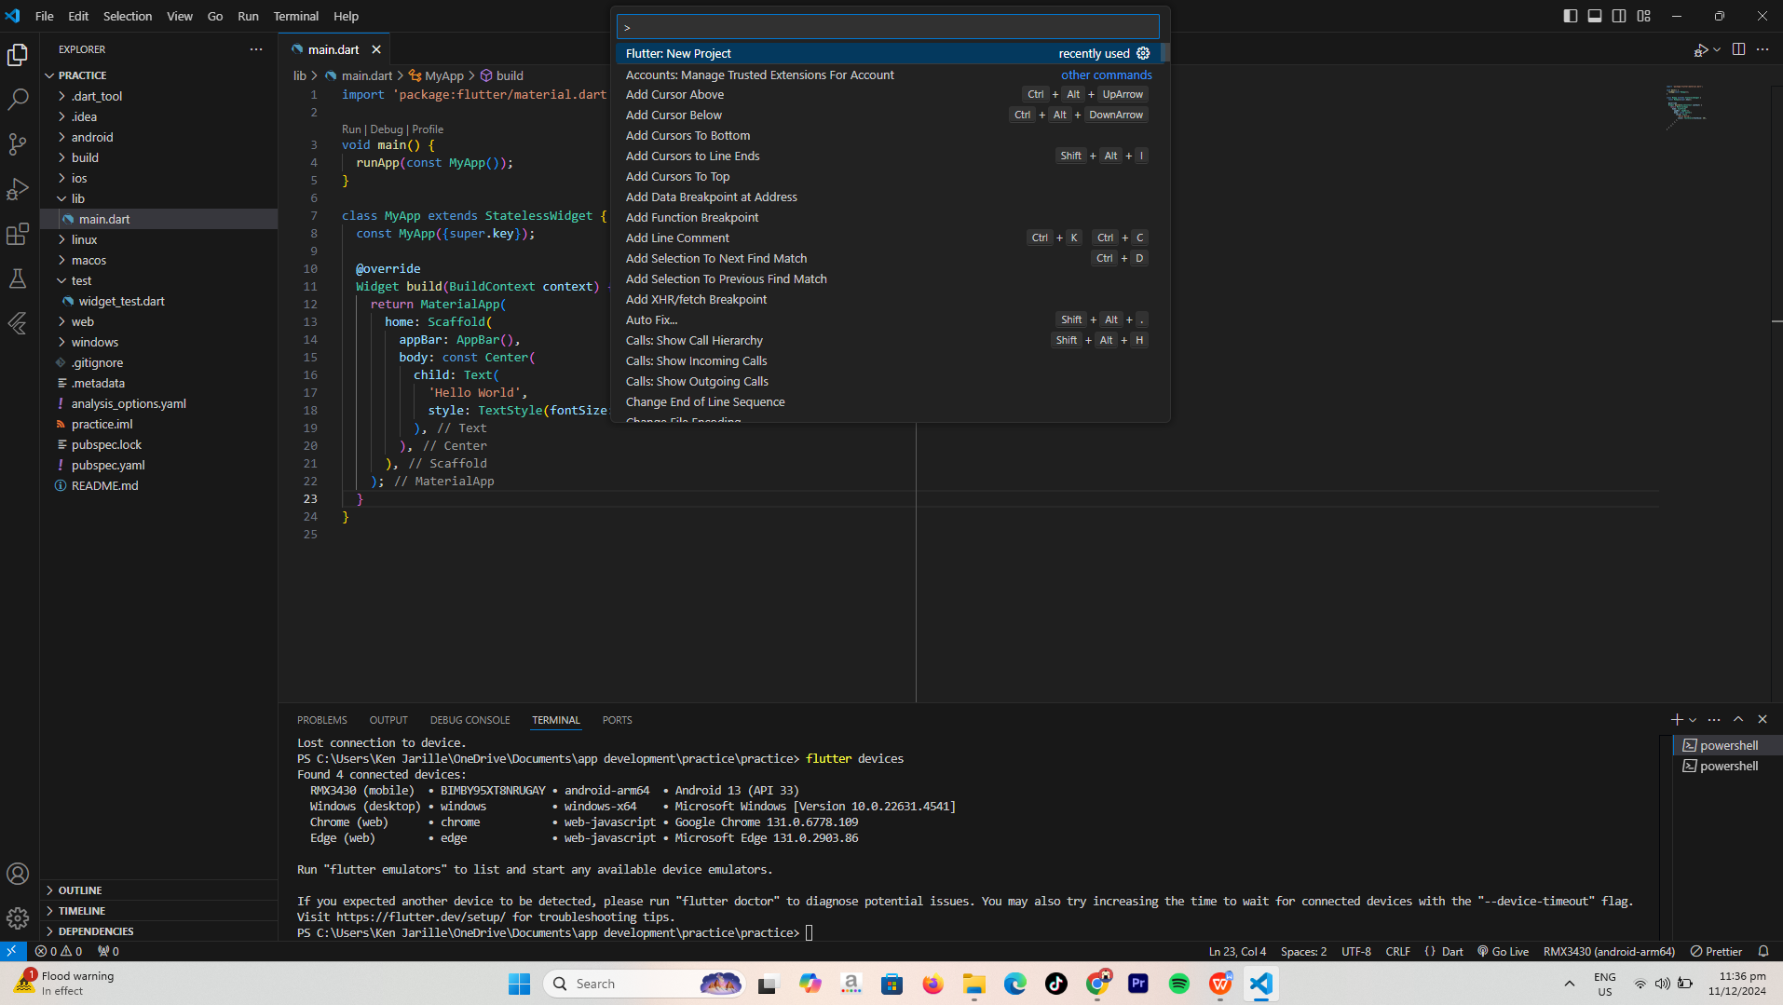then saved it the folder for easy redirecting  
  
  
  
  
  
  
  
  
  
  
  
  
  
  
  
  
  
  
  
  
  
  
  
  
  
  
  
  
  
  
  
  
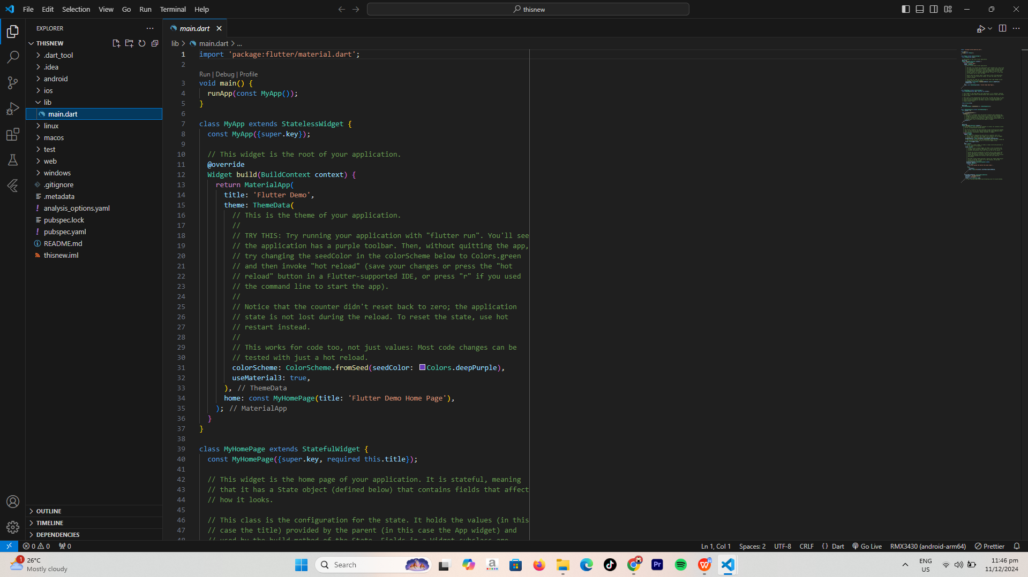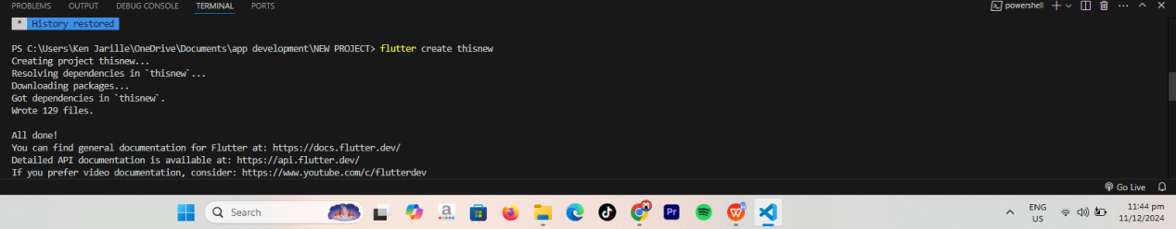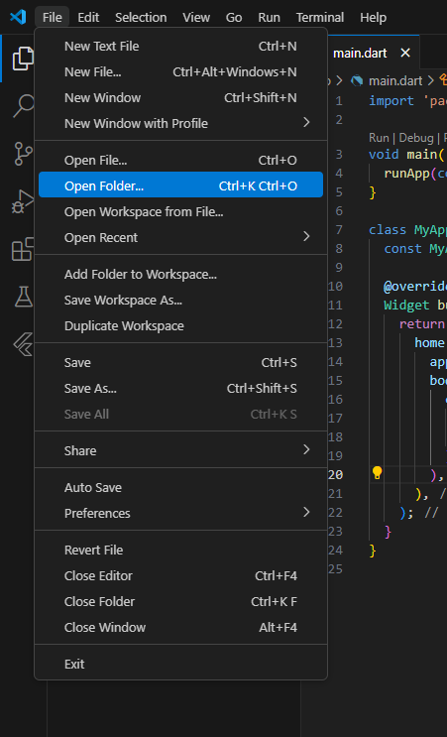THEN OPEN THE FOLDER  
  
  
  
  
  
  
  
  
  
  
  
  
  
  
  
  
  
  
  
  
  
  
  
  
  
THEN OPEN TERMINAL THEN TYPE FLUTTER CREATE TO CREATE FLUTTER PROJECT  
  
  
  
  
  
  
  
  
  
THEN I SUCCESFULLY CREATED A NEW FLUTTER PROJECT CALLED THISNEW